INF 424: Multimedia Programming
Technical Report
Student Name: VIRGINIAH MUENI
Adm Number: INF/006/2022
Academic Year: 2025/2026

Introduction and Application Overview
EduStream is a web-based multimedia learning hub developed to provide an engaging, interactive, and resource-rich educational environment by integrating various forms of digital media into a single platform. The application is designed using standard web technologies including HTML5, CSS3, and JavaScript, with a strong emphasis on multimedia integration, efficient content delivery, and modern web development practices. The system demonstrates how different types of media such as images, audio, and video can be effectively combined to enhance the learning experience and improve user engagement.
The primary objective of EduStream is to serve as a centralized platform where learners can access educational materials in multiple formats, thereby accommodating diverse learning preferences. Visual learners benefit from images and videos, auditory learners from audio content, and all users benefit from the interactive nature of the system. In addition to improving accessibility, the application also focuses on performance optimization, ensuring that media files are delivered efficiently without compromising quality.
The application is structured into multiple pages, each designed to showcase specific multimedia functionalities. The home page (index.html) acts as the main entry point, introducing users to the system and providing navigation to other sections. It demonstrates foundational multimedia elements and ensures proper HTML structure and styling. The gallery page focuses on image display, utilizing responsive image techniques and multiple file formats to optimize performance. The video page demonstrates the integration of video content using the HTML5 video element, including playback controls and event handling. The audio page incorporates both the standard HTML5 audio element and the Web Audio API to provide advanced sound manipulation capabilities. Finally, the about page provides background information about the system and its development.
A key feature of the application is the use of modern multimedia APIs and concepts. The <picture> element is used to deliver responsive images in different formats such as AVIF, WebP, and JPEG, allowing the browser to select the most efficient format based on compatibility. The HTML5 <video> and <audio> elements are used to embed temporal media, while JavaScript is employed to manage user interactions through event-driven programming. The Web Audio API is used to create and manipulate audio signals, demonstrating a more advanced level of multimedia processing. The project is deployed using GitHub Pages, making it accessible online and demonstrating real-world application deployment practices.

Non-Temporal and Temporal Media Analysis
Multimedia content is broadly categorized into non-temporal and temporal media, depending on how it behaves during rendering and interaction. Non-temporal media refers to static content that does not change over time, such as images, graphics, and text. Temporal media, on the other hand, refers to time-based content such as audio and video, which requires continuous playback and evolves over time.
In the EduStream application, non-temporal media is primarily represented by images displayed using the <img> and <picture> elements. These images are loaded once when the page is accessed and remain static unless explicitly changed by the user or the application. For example, the gallery page uses multiple image formats to ensure optimal performance and compatibility. Once an image is loaded, it does not require further data transfer, making it relatively simple to manage.

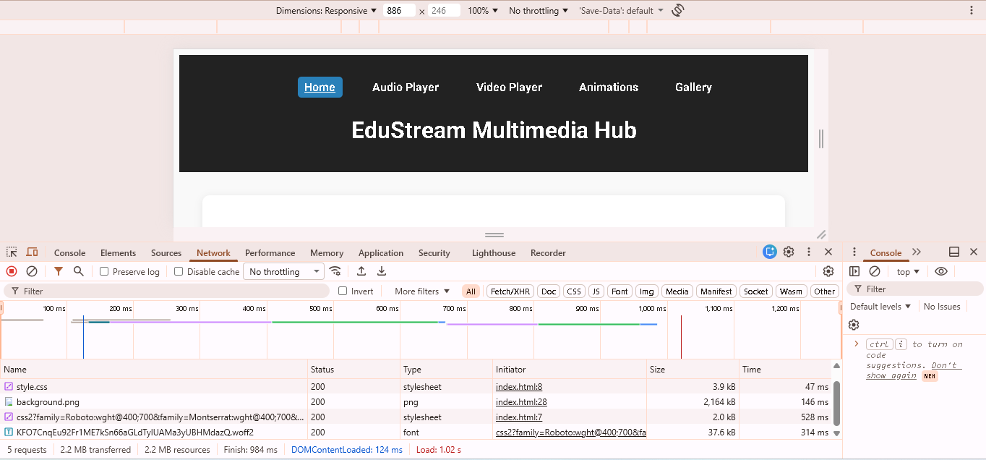

Temporal media, however, introduces a higher level of complexity. Video and audio elements require continuous data streaming and playback management. When a video is played, the browser does not load the entire file at once; instead, it loads portions of the content in chunks, a process known as buffering. This allows playback to begin quickly while the rest of the content continues to load in the background.
An analysis using the Chrome DevTools Network tab highlights the differences between these two types of media. When an image is loaded, it appears as a single network request with a fixed file size. In contrast, video files generate multiple requests as the content is streamed. This results in a more dynamic network activity pattern, reflecting the ongoing nature of temporal media.
Temporal media also requires additional event handling to manage different playback states. Events such as “play,” “pause,” “waiting,” and “ended” must be monitored to ensure smooth operation and a responsive user interface. For instance, when a video enters the buffering state, the application may display a loading indicator to inform the user. Similarly, when playback is paused or completed, the interface must update accordingly.
The increased complexity of temporal media stems from the need to manage time-based changes, synchronization, and user interaction. Unlike non-temporal media, which only requires a single rendering process, temporal media involves continuous updates and state transitions. This makes it more resource-intensive and requires more sophisticated programming techniques to handle effectively.

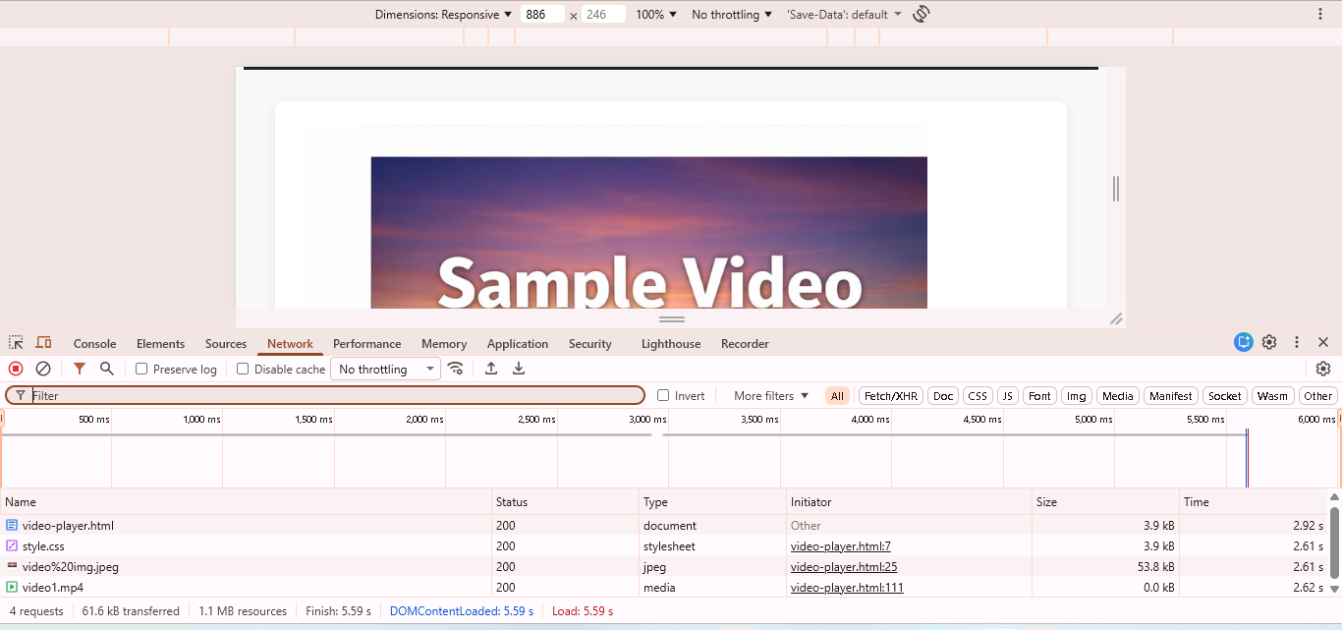

Media Format Selection Justification
The selection of appropriate media formats is a critical aspect of multimedia application development, as it directly impacts performance, quality, and compatibility. In the EduStream application, multiple image formats were used to balance these factors and ensure an optimal user experience.
JPEG format was chosen for photographic images due to its high compression efficiency. It significantly reduces file size while maintaining acceptable visual quality, making it suitable for images where minor quality loss is not noticeable. However, JPEG does not support transparency, which limits its use in certain scenarios.
PNG format was used for images that require transparency or high-quality detail. It uses lossless compression, meaning that no data is lost during compression, resulting in high-quality images. However, this comes at the cost of larger file sizes, which can impact loading performance.
WebP was selected as a modern alternative that offers better compression than both JPEG and PNG while supporting transparency. This makes it a versatile format that can be used in a wide range of scenarios. WebP images are typically smaller in size, leading to faster loading times and improved performance.
AVIF, a newer image format, was also included due to its superior compression capabilities. It provides even smaller file sizes than WebP while maintaining high visual quality. However, because not all browsers fully support AVIF, fallback formats such as WebP and JPEG were provided using the <picture> element. This ensures compatibility across different browsers while still taking advantage of advanced formats where supported.
SVG format was used for icons and vector graphics. Unlike raster images, SVG files are scalable without losing quality, making them ideal for responsive design. They also tend to have smaller file sizes and can be styled using CSS.
By combining these formats, the application achieves a balance between quality, performance, and compatibility. The use of responsive image techniques ensures that users receive the most appropriate format for their device and browser, reducing load times and improving the overall user experience.

Event-Driven Programming Analysis
Event-driven programming plays a crucial role in managing user interactions within the EduStream application, particularly in relation to multimedia elements such as video. This programming paradigm allows the application to respond dynamically to user actions and system events, ensuring a smooth and interactive experience.
The lifecycle of a video element involves several distinct states, beginning with the initialization of the video when the page loads. As the video loads, metadata such as duration and dimensions is retrieved. The video may then enter a buffering state if sufficient data is not yet available for playback. Once enough data has been loaded, the video enters the playing state, during which it continuously updates as it progresses. Users can pause and resume playback at any time, and eventually, the video reaches the ended state when playback is complete.
JavaScript event listeners are used to monitor these states and trigger appropriate responses. For example, the “play” event can be used to update the user interface to indicate that playback has started, while the “pause” event can update controls to reflect the paused state. The “waiting” event is particularly important, as it indicates that the video is buffering, allowing the application to display a loading indicator. The “ended” event signals that playback has finished, enabling the application to reset the video or suggest additional content.
Event-driven programming improves the responsiveness of the application by ensuring that actions are only taken when specific events occur. This reduces unnecessary processing and enhances performance. It also ensures that the user interface remains synchronized with the state of the media, providing a seamless experience.

Web Audio API Architecture
The Web Audio API is used in the EduStream application to provide advanced audio processing capabilities beyond what is possible with the standard HTML5 audio element. It allows developers to create, manipulate, and control audio signals in real time, enabling more interactive and dynamic audio experiences.
The architecture of the Web Audio API follows a signal flow model consisting of three main components: the source, processing nodes, and destination. The source is responsible for generating the audio signal. In this application, an OscillatorNode is used as the source, producing a continuous waveform such as a sine wave.
The generated signal is then passed through one or more processing nodes. A GainNode is used to control the volume of the audio signal. This node allows for precise adjustments to the amplitude of the sound, enabling features such as volume control and fading effects.
Finally, the processed signal is sent to the AudioContext destination, which outputs the sound to the user’s speakers or audio device. This structured approach allows for flexible and powerful audio manipulation.
An important aspect of the Web Audio API is gain ramping, which involves gradually changing the volume over time. This is achieved using methods such as linearRampToValueAtTime. Gain ramping is essential for preventing abrupt changes in sound, which can result in clicks or distortion. By smoothing transitions, it improves the overall audio quality and user experience.
Without gain ramping, audio transitions would be harsh and potentially unpleasant for users. This highlights the importance of proper audio processing techniques in multimedia applications.

Component Architecture Reflection
The EduStream application employs a component-based approach to improve code organization, maintainability, and scalability. Instead of writing repetitive HTML for each media item, reusable functions are used to generate content dynamically. This approach reduces redundancy and simplifies the process of updating the application.
For example, a function such as renderMediaCard can be used to create multiple media cards with consistent structure and styling. If changes are needed, such as modifying the layout or adding new features, they can be implemented in a single location and automatically applied to all instances.
In contrast, using hardcoded HTML would require manual updates across multiple sections of the code, increasing the risk of errors and inconsistencies. The component-based approach also improves performance when combined with event delegation. By attaching a single event listener to a parent element, the application can handle events for multiple child elements efficiently, reducing memory usage and improving performance.
The next step in enhancing the architecture would be to adopt modern JavaScript frameworks such as React or Vue. These frameworks are built around component-based design principles and provide additional features such as state management and reactive updates. This would further improve the scalability and maintainability of the application.

Conclusion
In conclusion, the EduStream multimedia learning hub successfully demonstrates the integration of various multimedia technologies into a cohesive and interactive web application. The project highlights the differences between non-temporal and temporal media, justifies the selection of appropriate media formats, and applies event-driven programming techniques to manage user interactions. The use of the Web Audio API demonstrates advanced audio processing capabilities, while the component-based architecture improves code organization and maintainability.
Overall, the application reflects best practices in multimedia programming and provides a strong foundation for further development. It meets the requirements of the multimedia programming and demonstrates a comprehensive understanding of modern web technologies and multimedia integration.

